All Saints Lutheran Church

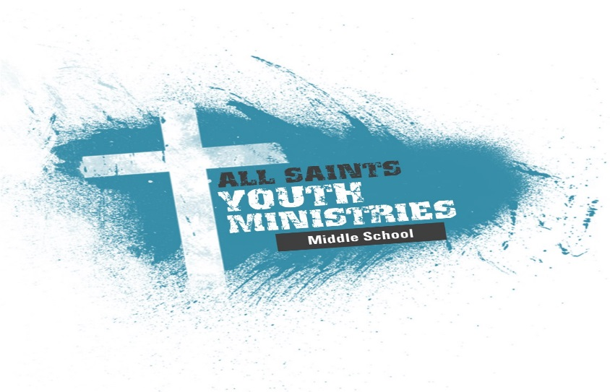

Confirmation Handbook
2019-2020

Welcome to Confirmation! When we were baptized the following words were spoken, “… to receive the gift of baptism, you are entrusted with the responsibilities:

-to live with them among God’s faithful people
-bring them to the word of God and the holy supper
-teach them the Lord’s Prayer, the Creed and the Ten Commandments
-place in their hands the holy scriptures
-nurture them in faith and prayer
So that your children may learn to trust God,
Proclaim Christ through thought, word and deed, care for others and the world and work for justice and peace.
Each of us as parents, sponsors and fellow brothers and sisters in Christ, make a promise at this time to support and teach the faith which has been passed down to us from generation to generation.

Parents:
This a great opportunity for you not only to set a great example but also to learn and grow along with your child by talking with, and working with, your child about what they are studying this year. The church can’t do this alone, if you want to increase your child’s potential for involving themselves in the faith, you need to be involved and make Confirmation a priority. Martin Luther created the Small Catechism as a tool that would help parents teach their children.

When you baptized your child, many promises were made by you and the church and we will help you fulfill these promises by providing instruction for your child. However, we will need your help in the process along the way too.

One of the ways in which you can be a positive influence in your child’s faith development is to be involved in the life of the church and grow as a disciple yourself. This means going to worship regularly, placing a priority on confirmation classes and events, attending adult studies, becoming involved in ministries that interest you, chaperoning retreats, events and service projects.

Another way to affect a positive influence is through sharing and discussing faith and this program in a positive way outside of church. We want this to be an opportunity for them to grow in their faith and not a burden.

Students:
Confirmation is a time where we seek to fulfill the promises that were made at your baptism. We are excited to work side by side with you and your family as you grow in your faith and understanding of the Christian faith. It’s our prayer that the years spent in the Confirmation program will create a solid foundation for your faith.

Questions:

What can I get out of Confirmation?
It is our hope that after going through the program you will clearly see what promises were made at your baptism and you will be ready to make those promises for yourself. You will have a basic understanding of our Lutheran beliefs and a good look into the Bible and what it has to offer. We also hope that in the program you will be able to surround yourself with other Christians your age and that will turn into friendships that will carry you into high school and college.

What am I expected to do?
You are expected to complete the requirements of the program, which include sermon notes, attending Confirmation class and Sunday School class and performing service hours. We do tell you how many requirements need to be done but please look at these as the minimum expectations, it’s our hope that Sunday School class is attended frequently and not just the minimum number needed for the program.

Why do I have to do all this?
It is our hope that this is not looked at as a burden or a chore, but maybe as a way of documenting what you feel about your relationship with God. The work that is asked of you has not been created to judge you or make it difficult on you, but we hope it is used as a tool in which you can track your commitment in your faith journey.

Confirmation is not a graduation; it is a statement of faith. Confirmation is meant to be a springboard for our faith journey which is lifelong. Confirmation is not a requirement, but it is a faithful response to our commitment to Christ.

2019-2020 Confirmation Requirements

6th grade:
6-sermon notes, attend 9-Sunday School classes, 7-confirmation classes, 8 service projects with 5 of those being done with the All Saints Middle School group and attending the 6th grade retreat.

7th grade:
7-sermon notes, attend 9-Sunday School classes, 7-confirmation classes, 8 service projects with 5 of those being done with the All Saints Middle School group and attending the 7th grade retreat.

8th grade:
8-sermon notes, attend 9-Sunday School classes, 7-confirmation classes, 8 service projects with 5 of those being done with the All Saints Middle School Group and attending the 8th grade retreat.

All Saints Middle School Service Projects
-Fleece Blanket Project
-Fall Festival
-Shopping and Delivering to the Huckleberry House
-Caroling
-Christmas Festival
-Christmas Program
-February Service Project (TBD)
-Easter Festival
-VBS (will count as 2)
-April Service Project (TBD)

The following is also considered service hours and can be used towards 3 projects: Ushers, Greeters, Readers, Blue Christmas Volunteer, Tools for School, Welcome Table and participating in one of the many Choirs.
Confirmation Covenant

The Confirmand’s Covenant:
I agree to:

-Attend a minimum of 5 Confirmation Classes and to actively participate in class
-Participate in Sunday School on a regular basis (minimum of 9 classes)
-Be involved in service within our congregation and community
-Keep my cell phone and any other electronic devices on silent during class.
-Show respect to all adult leaders, other students and the gathering space and to exhibit positive & polite behavior whenever I am involved in a church function.

The Parent’s Covenant:
I agree to

-Pray for my child, the other confirmands and the teachers.
-Openly share my faith with my child.
- Worship regularly with my child.
-To make Confirmation Classes, Sunday School Classes and Service events a priority.

The Faith Formation Team Covenant:
I agree to

-Pray for all confirmands, parents and teachers.
-Openly share my faith journey.
-Be involved in discipleship development and the other areas of life.

Middle School Ministry
2019-2020 Calendar of Events

September
6th All Middle School Lock In/Service Project
7th Confirmation Class #1
8th Sunday School Kick off/Front Lawn Festivities
8th High School Mission Trip Lunch/Informational Meeting (8th graders)
14th 6th Grade Party
15th Sunday School Classes Begin
29th MS Pancake Breakfast/Youth Group Outing - Canoeing @ Trapper John’s

October
5th Confirmation Class #2
13th Sunday School Christmas Program Try Outs
20th Youth Group Outing - Splatter Park
27th Fall Festival/Service Opportunity

November
1st Confirmation Class #3
16th Huckleberry House Christmas Shopping/Service

December
1st No Sunday School
7th Sunday School Christmas Program Dress Rehearsal
8th Sunday School Christmas Program/Service
14th Christmas Festival/Service
15th Christmas Party/Caroling/Service
22nd No Sunday School
23rd Blue Christmas
29th No Sunday School

January
4th Confirmation Class #4
10th-12th Quake
26th Youth Group Outing – Lazer Kraze

February
1st Confirmation Class #5
1st Sub Making (8th graders attending High School Mission Trip)
8th-9th 7th Grade Retreat
23rd Service Project (TBD)

March
7th Confirmation Class #6
7th Youth Group Outing (TBD)
14th-15th 8th Grade Confirmation Retreat

April
4th Confirmation Class #7
11th Easter Festival/Service
12th Happy Easter/No Sunday School
14th Confirmation Rehearsal Dinner
19th Last Day of Middle School Sunday School
26th Confirmation Sunday
26th 8th Grade Welcome to Youth Group

June
15th – 19th Vacation Bible School

July
11th-19th High School Mission Trip (8th Graders)

The Faith Formation Team will be using Remind 101,
As well as email, to help Parents and Youth keep up-to-date with all events and updates for middle school and confirmation. Remind is a free text messaging app that helps our Faith Formation Team, youth, and parents communicate quickly and efficiently. Please subscribe to:

REMIND 101
Enter this number:
81010
Text this message:
@middleyou

You should receive a confirmation text immediately following.

Also follow us on Instagram @ saintsonhighyouth

I would like my child to participate in the 2019-2020 Confirmation program at All Saints Lutheran Church. I have read the requirements and know what is expected to complete each year of the program. I have read and agree with the Confirmation Covenant and a statement of why we would like _____________ to be Confirmed.

__________________________________________________________
____________________________________________________________________________________________________________________
__________________________________________________________

Students Signature & Date

Parents Signature & Date

__________________________________________________________
Faith Formation Team Signature & Date

